The Poverty Program
March 2007

PROGRAM SCHEDULE
APR 15, 2 PM BELLEVILLE CHURCH, chairperson Bob Crofts
GLOBALIZATION, POVERTY AND DEBT
MAY 20, 2 PM UNITARIAN CHURCH, chairperson Rob Burnham
HUMAN RIGHTS - Movie SOLDIER CHILDREN
JUN TBA Quaker Meeting House, chairperson Sam Baily
ARMS TRADE - Movie LORD OF WAR
JUL 22, 6:30 PM Cong. Ahavas Achim, chairperson Rabbi Stanley Sadinsky
genocide - Movie darfur diaries
AUG 19, 2PM TBA, chairperson Whitney Erskine
AIDS/HIV - Movie facing aids
SEP 16, 2 PM BELLEVILLE CHURCH, chairperson Helen Hatcher
UN Peace Event- Movie PEACE ONE DAY
OCT TBA: UNITARIAN CHURCH, chairperson Rob Burnham
Millennium Goals, Vol. Job Fair
NOV TBA: Coming Together Event
If you would like to become involved with any of the programs,
email povertyprogram@gmail.com.
GLOBALIZATION, POVERTY AND DEBT
APRIL 15th, 2PM
BELLEVILLE CHURCH
Bob Crofts, economics professor at Salem State College, will be presenting the program on globalization, poverty and debt. Globalization is controversial; it's praised by some, protested by others. It can sometimes alleviate poverty and sometimes cause poverty. It can be beneficial in the long run but painful to adjust to in the short run. Do the long run gains outweigh the short run pains? We will analyze both sides of globalization and view the Paul Solman DVD, The Trials and Tribulations of Trade
The second Paul Solman movie, IMF Rescues Jamaica, will look at Jamaica and the International Monetary Fund. Has the IMF rescued Jamaica or put Jamaica into a deeper financial hole? We will also look at the issues of debt forgiveness and the idea of microlending.
And, if time permits, we will look at the issue of capitalism vs. socialism to alleviate poverty in the 3rd world. This applies to the current movement in Venezuela (and some other Latin America countries) to socialism as a way to reduce poverty. This will involve a 3rd Paul Solman video: The Cuban Quandary.
Let’s all try to attend the April 15 presentation!

Contents:
Program Schedule 1
Website Update 2
March Program – Education 2
February Program Follow-up 4
BEADS for Education 6
Teaching Mission in Mexico 7
A Refugee With Hope 8
Gorillas, Guns, and Gabbing 10
Upcoming Events 11
Volunteering 12
Action Alerts 12
Children’s News 13
Book and Movie Recommendations: 13

POVERTY PROGRAM UPDATE
WEBSITE
povertyprogram.com
The website is up and running although some sections are still works in progress! Tania Harrison has done a fantastic job creating this website for us and will be maintaining it. The purpose of the website is three-fold: first to educate, publicize social and moral issues events that impact poverty here at home and in the world; second, a website for use by the Doyle Center and other service organizations in the area to list their services and their volunteer needs; and third as a central place to list community events that impact issues of poverty and social, moral issues. The website has:
- calendar of events - email us by the 20th if you would like an event listed;
- poverty program newsletter and archived newsletters. Articles, pictures, book/movie recommendations must be submitted by the 15th.
- section on donating and volunteering. Charities: please send us your volunteering opportunities and information, and web link for your charity. We will be highlighting a volunteering opportunity each month so if your organization would like to have a volunteer opportunity highlighted, email us the information by the 15th ;
- children’s page - we are looking for a volunteer children’s page editor as well as articles, pictures, again submit by the 15th;
- poverty information and statistics;
- a special section for charities to list their organization, what they do, what they need, how volunteers can help. Please send us your information if you would like to be listed!

March Program: Education and Poverty

Ross Varney, pastor of the Belleville Church and this month’s chairperson, gave an introduction on American education, his experiences as a teacher, followed by Gail Gandolfi and Sue Heersink (see Sue’s and Gail’s articles below) and the movie, Boys of Baraka. Ross pointed out that 1 in 10 students in Newburyport don’t graduate while better than Triton’s (1 in 8) statistics, still isn’t good. He also stated that across the US only 30% of college graduates can read, retain and understand complex books. Ross, having taught in a private school, stated that class size is crucial and with the current cutbacks in Newburyport, this will have an impact on the education of students. “It is really hard to meet all the needs, of all the students, in a larger class”. Some classes in Newburyport, for instance the art and music classes, have a ratio of one teacher to 70 students.
The lack of an education can lead to homelessness, for instance, when a person cannot fill out a job application; to sickness, when people are unable to read or obtain health and self-care information; he has dealt with some people in such circumstances, Ross said. A former language teacher himself, he commented that language programs, which are being eliminated for reasons of cost, are a “door that opens up to the world.” The lack of people’s understanding of languages and foreign cultures has a bad effect on foreign policy.
These sorts of budgetary issues go far back, he commented; his father was a high school principal and his grandfather a superintendent, and they had to deal with such problems, too. “Why, in a town like this, do we have to fight for the budget?” The educational system affects all of us, not just people with children in the schools. He commented that the new education chancellor in Brooklyn, NY wants to increase the number – and the quality – of teachers. He asks students, “How many teachers really care about you?”
The UN Convention on the Rights of Children states that all children have the right to a primary education and should have the right to secondary education.

American Education Statistics:
- Not graduating from high school raises the chance of living in poverty to 49%.
- Education at a Glance, an annual report done annually: “More than a quarter of 15-year-olds in the United States…. performed at or below the lowest levels on math and problem solving and students from poor families were 3.5 times more likely to do badly.
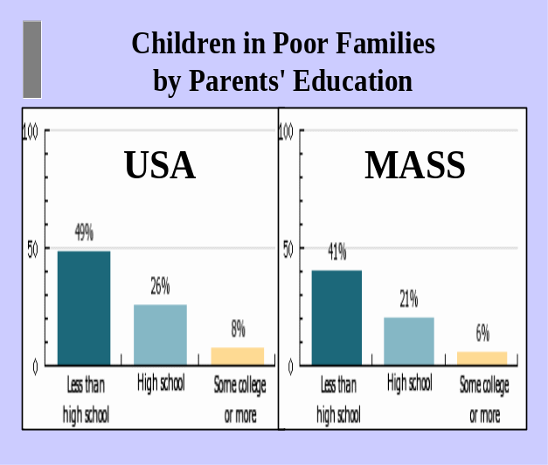
- “Adults who do not finish high school in the United States earn 65 percent of what people make if they do finish high school. No other country had such a severe income gap.”
- Washington Post article, 12/25/05: 69% of our college graduates can not read, think and analyze a complex book. The U.S. spends more per student from elementary school through college than all countries except Switzerland

Third World Statistics:
- Africa has the youngest population in the world and as of 2005, 46 million African children had never even stepped into a classroom.
- Only 60% of Third World girls are in school, worldwide 115 million primary -school age children are not in school.
- The higher the literacy level of a mother, the lower the chance of her child dying or living in poverty.
- Children with education mothers are 50% more likely to live past the age of 5.
- 100 million children are not in school with girls making up 60% of those not in school.
- Classrooms are often overcrowded 60:1.
- Obstacles to education: school fees; children having to work; no local schools; shortage of well-trained teachers, unsafe conditions.
- 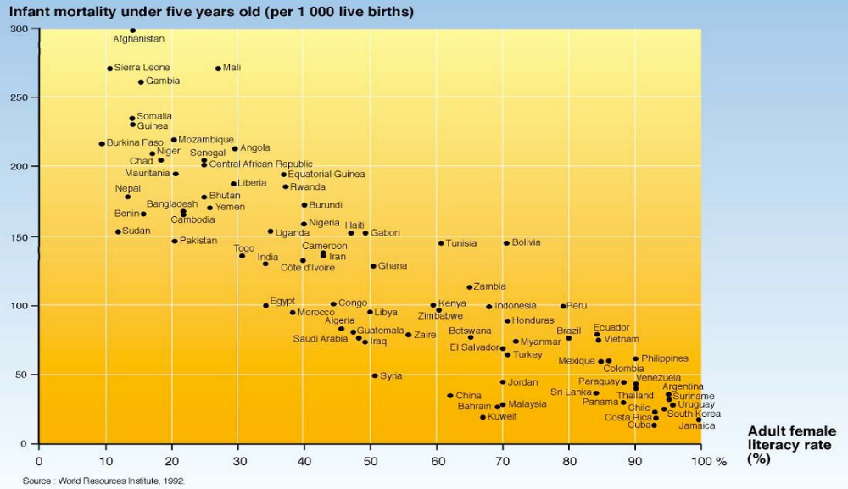In the Third World teacher pay is as low as $2 a day.
- In Zambia, more teachers are dying from AIDS than are being trained to teach.
- 64% of the 771 million adults who are illiterate are women.
- Education is crucial in ending the cycle of poverty.
- Educated women have smaller, healthier families.
In many parts of the world, people live on 1-2 dollars a day. Many students walk miles to and from school if they are lucky enough to afford the school fees and the costs of books and uniforms. Donating your spare change can make an enormous difference in these children’s lives and in their ability to have an education. Every dollar, every quarter makes a difference, please donate what you can.
Thanks to the many people who made this program a success!

FEBRUARY PROGRAM FOLLOW UP
- A question regarding whether food from area restaurants, farms is being recycled to the food pantry or meal programs. Donna Sylvester did not believe that this was being done. The Poverty Program has emailed Second Harvest to get information on starting a food recycling program in the area.
- A question about regarding the nutrition in the area schools was also raised and the Poverty Program has contacted the Newburyport Superintendent.
- Ed Cameron stated that one thing that people could do to help the homeless would be to contact State Representative, Mike Costello and ask him what he is doing about homelessness. See below for Mike Costello’s response:

Catherine:

Ed and I had a meeting regarding this very issue in my Boston office a short time ago. Ed is a great resource on this and I look forward to working with him on this issue. I think one of the problems was that the last administration cut resources for these valuable programs. I think that Governor Deval Patrick is committed to restoring and enhancing programs that help the homless and people with low income. Below I have included some information about measures the Governor has already taken to improve the housing situation in Massachusetts. I look forward to working with the Governor to address these issues. *******************************************************************************************************
LEGISLATORS EYE PLAN TO SPEND $1.25 BILLION ON HOUSING OVER FIVE YEARS
By Gintautas Dumcius
STATE HOUSE NEWS SERVICE
STATE HOUSE, BOSTON, FEB. 27, 2007…..Legislative leaders Tuesday confirmed plans to advance a five-year plan that would pour $1.25 billion into state affordable housing, modernization, preservation and stabilization funds.
Rep. Kevin Honan (D-Brighton), co-chair of the Joint Committee on Housing, is hoping to move quickly on an omnibus $1.25 billion bond bill, and sponsors of the bill hope the Patrick administration will boost annual housing bond spending to $200 million, up from the current $130 million.
The bill, sponsored by Honan, Sen. Brian Joyce (D-Milton) and 68 co-sponsors, also puts $245 million toward the affordable housing trust fund, expands the state’s low-income housing tax credit by $6 million and makes the tax credit permanent by removing a 2010 sunset clause.
The Housing Committee plans to hold a public hearing on the bill March 14.
The bill would include $500 million for modernization and $125 million for grants or loans for homeownership, purchase, preservation and rehabilitation of properties, and require the administration to file a yearly capital plan with the Legislature.
“It’s something we need desperately,” Michael McLaughlin, executive director of the Chelsea Housing Authority, told the Housing Committee at an informational hearing held in Gardner Auditorium.
Advocates say the state has allowed the public housing buildings, which collectively feature 50,000 units of housing, to deteriorate through chronic underfunding and under-subsidization, forcing the authorities to take numerous units offline. Three of the state’s largest authorities – Boston, Cambridge, and Brookline – are suing the state for allegedly not meeting contractual requirements over funding.
The bill also requires MassHousing, the state’s affordable housing bank, to pay either $10 million or 10 percent of its reserves into the state General Fund and requires the agency to annually report the payments.
Honan said the bill will also have to make stops at other committees, including the Joint Committee on Bonding, Capital Expenditure and State Assets.
“That’s absolutely going to happen,” Sen. Susan Tucker (D-Andover), committee co-chair, said of the bond bill, but adding that it may have to wait until after state budget deliberations.
“It is slow,” she said of the budget process. “We’re talking about July, but the housing authorities should be optimistic.”
Lawmakers and advocates are also pushing a bill from Sen. Harriette Chandler and Rep. Jeffery Sanchez to eliminate the “red tape” authorities face through regulations and statutory requirements when dealing with the state Department of Housing and Community Development (DHCD).
“It isn’t just the funding,” McLaughlin said. “The structure on the state level has to be simplified. You do not have that at DHCD.”
The bill would allow for “predictable funding schedules,” an annual plan the authority prepares and DHCD signs off on, an annual report submitted to the agency, and innovative programs. The bill also provides for a seven-member advisory committee to provide advice on regulations to the DHCD.
Joyce has also filed a bill to authorize a local option for housing authorities: charging a minimum $300 security deposit, in response to evicted tenants in family developments who trash their apartments before leaving, which can take apartments offline.
With Gov. Patrick set to outline his budget tonight in a televised address from Melrose, public housing advocates and lawmakers said they are optimistic of funding increases for housing subsidies. Last year, the Legislature provided $55 million in operating subsidies.
“There’s always a struggle for limited resources,” Honan said. “The competition is fierce and it’s going to be a tight budget.”
Sen. Steven Panagiotakos (D-Lowell) said, “We’re going to have to make some priorities. To me, that’s a priority.”
Tucker said she has reason to believe Gov. Deval Patrick will increase housing funds. “I think he recognizes the plight of the housing authorities,” she said.
“Deval Patrick has made it very clear this is one of his priorities,” said Tom Connelly, the head of the Massachusetts chapter of the National Association of Housing and Redevelopment Officials. “We’re all going to be watching TV tonight,” he said.
*******************************************************************************************************
February 28, 2007
Public Housing Prioritized in Governor Patrick's First Budget
Citizens' Housing and Planning Association (CHAPA) applauds Governor Deval Patrick's first budget for providing significant funding increases for affordable housing production and preservation, which are greatly needed to address the growing housing needs of Massachusetts residents.

The Department of Housing and Community Development (DHCD) would receive $124.9 million in direct budget appropriations under the Governor's proposal, compared to $111.6 million in FY '07 (not including supplemental budgets). Most programs are level-funded; however, there is a $15 million (33%) increase in funding for state public housing. Though not included specifically in the budget, Governor Patrick publicly stated that $40 million in new funds will be made available from MassHousing for the Affordable Housing Trust Fund and that the SoftSecond Home Mortgage Program will also receive an increase though funds to be provided by the Massachusetts Housing Partnership. Administration officials have also indicated that the bond cap will be increased for public housing modernization.

The Governor's budget also proposes to merge various line-items, including the Massachusetts Rental Voucher Program, Residential Assistance for Families in Transition, the Tenancy Preservation Program, the Individual Development Account Program, and the Housing Services line-item (which includes the Housing Consumer Education Centers) into one consolidated account. To the Administration's credit, the funds in the new Homelessness Prevention and Elimination Services account exceed what was included last year in the individual accounts by $2.4 million.

Sincerely,
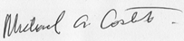

ARTICLES
BEADS FOR EDUCATION
by Sue Heersink
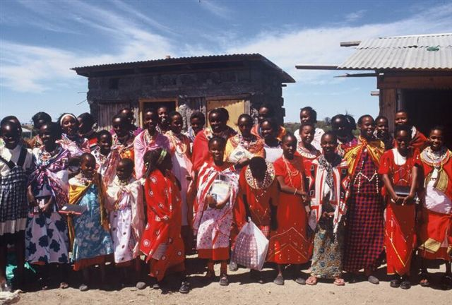I had the opportunity to work with BEADS in Kenya for three weeks in January. BEADS ( Beads for Education, Advancement , Development and Success)was founded by my sister, Debby Rooney in 1991. Its purpose is to help Maasai girls get an education by finding sponsors for them. Otherwise these girls would be unable to afford the modest cost of schooling and would have an arranged marriage at twelve or thirteen. Currently 270 girls, some as young as six, are sponsored for the duration of their education. Each sponsorship costs $360 for the student’s room, board and education per year. Though Kenya has free public schooling through grade 8, it is not of sufficient quality.

BEADS’ sponsored girls attend modest but academically good boarding schools. Six girls graduated from high school in 2005, two in 2006 and nine more in January 2007. There is a year between high school graduation and college entrance and during that year the graduates become interns. First they assist teachers at Topride Academy, a good school with a fine staff that 150 of the BEADS student attend. From January through March they learn how to teach in classes from nursery through Class 8. Then these interns go out to teach for one year in one of 3 schools- the town’s public elementary school, or one of two very remote and rudimentary schools.

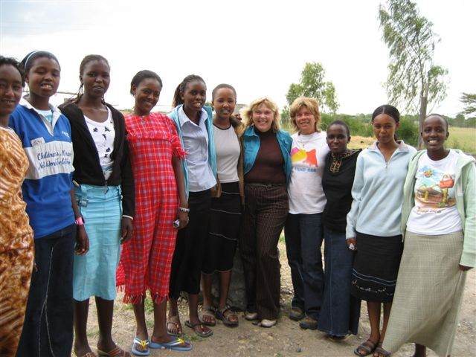
That’s where I come in. In January 2005, May 2005 and again in January of 2007 I helped train the interns to prepare them for their teaching experience. It is a very exciting and rewarding time. Every day, the ten of us met from 9:00 till 5:00 (of course with a break for tea and lunch) to learn various teaching strategies. My efforts are mainly concerned with reading and books. All year I have the exquisite pleasure of choosing and purchasing books for Topride. We now have one of the few lending libraries (5,000 books in an 8’ by 8’ room) in the area. It sounds modest by American standards but, one hour outside of Nairobi at a school with 350 students, it is immense. The parents of many of these students are illiterate. Owning a book, hearing a bed-time story read aloud, or learning to love literature are outside the normal scope. Each time I go, I take 7 or 8 suitcases filled with books. It’s like packing a space ship- each book must be considered carefully for its worth. So many favorites that we grew up with have found their way there: Charlotte’s Web, The Very Hungry Caterpillar, Helen Keller’s Teacher, Stone Soup and thousands of others sit on Topride’s newly constructed shelves.
Sue and Deb with the 9 high school graduates who are now interning for BEADS as teachers in the public schools.

Library Day is really amazing. Long lines of students queue up for their turn -- 5 pupils at one time fills the entire library space. Since the children have not had exposure to a wide variety of books, the love of books must be kindled, so we promote some basic principles: 1. Reading aloud (by the teacher) each day, 2. silent reading by the students each day. These seem like simple and natural ways to promote reading but they are just taking root. Now that we have many book series (15 copies of each), they can go into the appropriate classrooms. The interns are taught to appreciate the books during my time with them, so they will know what they have available to use. We practice reading aloud in a way that makes the story come alive; how to share illustrations with the class; how to try to be creative and imaginative. For example, we act out parts of the story: we were bulls and matadors for Ferdinand; cows, sheep and horses for Charlotte’s Web; we used the first felt board ever for Billy Goats Gruff, and pretended to paddle huge Polynesian canoes while surrounded by vicious sharks (a hard concept for students living 1,000 miles from the sea) for Call It Courage. In the evenings, I would show the interns a technique. The next day, these 18-year-olds would try it out in a Topride class and would return by lunch, flushed with success: “They liked it!”, “They understood!”, “They wanted to know if you could really make soup from a stone”. My answer: “Well, let’s try it.” And we did.

When these nine young women go out to the rural schools, some with only mud walls, no desks or blackboards, they will have to use their wits and ingenuity. We tried to enhance these attributes, asking: “What can you do with nothing?” In the large sturdy plastic bags purchased at the Dollar Store here in Newburyport, each of them has their “teacher survival kit”: a pair of scissors, 25 nails, 6 cup hooks, 2 magic markers, 6 pens, an alphabet chart, a precious bar of soap, and their teacher’s notes. Hopefully, they will be ready. I look forward to getting to know the next group of interns from the graduating class of 2008.

BEADS for Education, 5501 Ventnor Avenue, Ventnor , New Jersey 08406 www.beadsforeducation.org

Debby Rooney doesn’t have children of her own, but that hasn’t stopped her Maasai friends in Kenya from bestowing her with the honorific “Mother of Many Girls”. As co-founder of the nonprofit Beads for Education, Rooney has coordinated private school funding (avoiding the poor quality of most of Kenyans public schools) of more than 280 Maasai girls in the last 13 years. Each sponsored girl is guaranteed school fees until her education is completed, including college “ instead of marrying as young as 13. The organization coordinates direct sponsorships linking girls with individual sponsors. BEADS also provides critical programs for the sponsored girls which include HIV/AIDS education, FOM awareness training and ceremonies without the traditional cutting,, and community service programs to mention a few.
Rooney, whose first career was as a teacher and environmental educator, found a new way to help the planet. I came to the realization that the fastest way to improve the environment is to educate girls, she says. For each year of education, a woman has fewer children, which reduces consumption of resources and saves the environment and improves the economic status of the family and community. Rooney leads several trips each year to introduce donors to the girls they support. The rewards from the project are just so amazing, says Rooney, when you think that none of these girls would have continued past eighth grade.
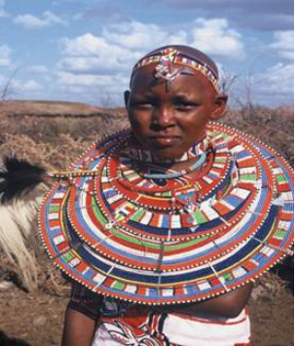

Beads for Education also offers business development training for Maasai women and the hand crafts have been named a top gift by O, The Oprah Magazine., The beaded purses, jewelry, housewares, and key chains are sold through the organization Web site (www.beadsforeducationorg ) and at Smithsonian Museum gift shops.

Teaching Mission in Mexico
by Gail Gandolfi
I have partnered with Tates Creek Presbyterian Church in Kentucky since 2001 and have done mission work in a little village called Xocempich in the Yucatan in Mexico. Xocempich is about 3 hours from Cancun. Cars, television, and cell phones are rare. Villagers live in thatched roof huts with dirt floors and twig walls or concrete cinder block homes. Homes surround two plazas… one has a field for playing soccer and a basketball court and the other plaza contains a defunct boys missionary preparatory school. Funds were misappropriated and the once thriving boys school complete with dormitory and swimming pool lies empty. The group I go with uses the concrete bleachers to house an audience when they perform their Vacation Bible School classes. There is also a teaching nursing clinic which presently has 8 students, and elementary and a middle school. The small Presbyterian church hasn’t had a minister since I have been going there.

When I began going to Mexico, my major goal was to build relationships with a people whose culture is very different from mine. My role has evolved over time and now I am in charge of the ESL-English as a second language program in the middle school. Teaching in Mexico is very different from teaching in the United States. In this village there are no classes for the learning disabled, autistic, deaf, retarded or those marginalized in a any way. Those children simply do not go to school. Some practical things I have learned in Mexico is that it is not a good idea to be prompt. Children drift in for school at a leisurely pace which translated into starting my teaching lessons over again to include latecomers. Then there is the heat! For some reason students shuttered all the windows and closed the door when I began to teach this past February… I was sweating so profusely that I wondered if my front row students might not think I was ill with a fever!

Middle school children in Xocempich are now in three classes. Their ages run from 11- 17. When I first started teaching we had a handful of students and one teacher. Now there are 3 teachers that travel a distance to teach these students whose numbers have grown. After middle school the next step is not high school like in the US. High school costs money for copias (copies of books), uniforms, which the mothers make if their child is lucky enough to go on to high school and there are also transportation costs as students go by taxi to the high school which is about ten miles away. Few children go on to high school. High School costs between $275-$600 a year. Belleville Church has sponsored Brianda for 3 years at a technical school in Mereda which is over an hour and a half from Xocempich. She is an incredible success story. The trend I have seen is that more and more children would like to have the opportunity to go to school however parents do not always encourage their children to pursue education.

When I first came to Xocempich many children did not even go to middle school after the first year. It is hard to imagine ending your education in the US at the age of 12. When food and shelter and clothing are a major concern, education is a luxury. Next year’s graduating class has the most promising group of students I have ever met. There is Evaristo, Miguel, Christina, Sonia, Cyntia and Patricia. My goal is to provide them the opportunity to go to high school through scholarships. My question to you is, how do I choose who gets that chance?

Xocempich education sponsorhip
Education is crucial to ending the cycle of poverty.
If you would like to sponsor or co-sponsor a child from Xocempich, please contact Gail Gandolfi at 978-462-2828.

A REFUGEE WITH HOPE
by Edo Kombana Mokonzi
I come from Kinshasa, the Democratic Republic of the Congo. Over the past decade Central Africa has been confronted with terrible, ongoing economic crises caused by civil wars and the opportunistic nature of the various multinational companies who have illegally taken my county’s natural resources for their own profit. The result of these ongoing conflicts has displaced thousands of people within my country.

After earning degrees in business administration and economics, I had many years of professional experience serving in the government and the private sector; operating and managing non-profit organizations within Africa and across Europe. I am currently a director of a non-governmental organization known as the Shalupe Foundation. Shalupe means “lifeboat.” Shalupe’s mission is “to bring help to every needy person in the Democratic Republic of Congo: the poor, the hungry, the sick, the naked, the hopeless, the homeless, and those who weep...and carry them to safety in our lifeboat.” While working for Shalupe in DR Congo, I used my ideas about microfinance to help poor people and refugees start their own small businesses.

I do not yet feel comfortable in explaining why I had to leave my country so suddenly. After being so accomplished, I came here as a refugee. I had not experienced how difficult it is to find meaningful work and steady employment. It is hard to comprehend the frustration one feels in trying to make a new life. Not until I arrived here, and not even speaking English, did I have a full understanding of the real struggles one has to go through just to stay warm and fed. I can’t tell you more strongly how demeaning it feels to have to accept a job that is well below one’s level of training and experience just in order to survive. If you are black and speak a different language, you can easily be misunderstood or taken for being less educated than you really are! It is most unfortunate that this is the case in such a rich country with so many opportunities available.

Even though I am in the U.S. now, I am still actively helping the people in my country and all the refugees who arrive here. I help to find them jobs, clothing, shelter, food and safe places to live. I care so deeply about helping people make better lives for themselves, and I hope to bring awareness to others who can support my efforts in this regard.

There is no greater gift than to see the happiness I can bring to those who are so desperately struggling to be successful after going through such trauma and upset with their families. I have been so fortunate to have made friends here and despite the trauma my country still goes through, I have hope that we can all support one another.

SHALUPE FOUNDATION
The Shalupe Foundation was founded in 2000. Through the generous gifts and contributions of members, we provide support:
- 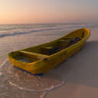for displaced individuals and families who are here in the United States as refugees;
- support two shelters in Kinshasa, DRC for displaced families of the the war, windows and orphans;
- donate desperately needed material for hospitals in the DRC;
- help pay for healthcare costs of those in need;
- shelter and support secondary and university students who are refugees in the USA.
- advocate for laws and policies regarding the DRC.
The Shalupe Foundation is in need of help with tutoring, ESL, advocacy, as well as financial contributions which are always welcome. All donations are tax deductible.
60 Elm Knoll Rd., Braintree, MA 02184 www.shalupe.org

DRC PEOPLE
- Since 1998 4 million people have died from famine, conflict violence, disease.
- Homes, schools, markets, hospitals have been looted and destroyed.
- 1,200 people die daily from epidemics and conflicts.
- Estimated 8,000 children remain as child soldiers.
- 3 million people have been injured by landmines and other unexploded ordnances.
- Literacy: 65.5%.
- 26.9 gross school enrollment ratio.
- 4.4 million children not in school.
- 1.1 million with HIV; 5% of population.
- 31% of children under 5 are underweight.
- Life expectancy 44.
- Births per woman: 6.7. High maternal mortality rate.
- Infant mortality rate 129 per 1,000.
- 16% of children under 5 have severe malnutrition.
- Measles immunization rate (’04) 64%.
- 42% urban access to sanitation.
- 54% don’t have access to clean water.
- 37% of population have phone access.
- 80% of population live on less than $1 a day.

DRC STATISTICS
- One-fourth size of USA.
- Vast natural resources: cobalt, copper, niobium, tantalum, petroleum, industrial & gem diamonds, gold, silver, zinc, manganese, tin, Coltan, uranium, coal, hydropower, natural gas, timber. Vast potential wealth from natural resources.
- Natural hazards: flooding, droughts, volcanic activity.
- Environmental issues: poaching threatens wildlife populations; water polution; refugees responsible for significant deforestation; soil erosion; mineral mining causing environmental damage.

GORILLAS, GUNS, AND GABBING
by Catherine Gould
What do gorillas, guns and gabbing have to do with each other and directly with each one of us? Coltan. Ever heard of it? Coltan is a rare mineral that has the unique quality of holding an electrical charge and is a vital component that is used in every, single cell phone and also is used in computers. In order for your cell phone to work, in 1998, 525 tons of coltan had to be mined and the DR Congo has the fourth largest reserves of Coltan. Have you seen the movie Blood Diamonds? For those who have seen it, imagine Coltan, not diamonds being mined. Coltan is mined in much the same way as diamonds: scrap the surface mud, slosh water about, and the Coltan settles. Many of the miners are children.

 Coltan is worth about $100 per kilogram and a miner can earn about $200 a month compared to most Congolese’s salary of about $10 a month. Coltan is mined by hand in a region of the DR Congo, the Kahuzi Biega National Park, which just happens to be the home of the rare, almost extinct mountain gorilla. The gorilla population has been cut in half, and only 3,000 remain. The population is decreasing due to deforestation to make mining easier as well as the military groups and miners have been hunting and killing the gorillas for food. An American company, Kemet, is now demanding that the Coltan they purchase is “gorilla safe”.

Officially at least the war in the DRC is over, having lasted from 1998-2003, 4 million people dead. The area that is being mined is in rebel held territory of the DRC. One report states that the Rwanda army made $250 million dollars in 18 months from selling Coltan even though there isn’t any Coltan in Rwanda. The Ugandan and Burundi military is also involved in the selling and transport of Coltan to Belgium. Global Issues states: “Rebels have driven farmers off their Coltan-rich land and attacked villages in a civil war raging, in part, over control of strategic mining areas… The link between the bloodshed and Coltan is causing alarm among high-tech manufacturers. Slowly they are beginning to grapple with the possibility that their products may contain the tainted fruits of civil war.” And a UN report states that: “the rebel groups' use of forced labor, illegal monopolies and civilian murder in their high-stakes game to extract this valuable resource”. Leonard She Okitundu, the Congo's minister for foreign affairs and international cooperation, stated in 2001 that “"a consensus was clearly emerging in the council and in the international community on the links between the shameless looting of Congolese natural wealth and the massacres of the Congolese people." He continued to say that "assassinations of civilians, deportations, torture, rape and deliberate spreading of HIV/AIDS, as well as the displacement of millions of refugees” are directly related to Coltan mining and rebel groups are involved in every step of the process before the Coltan leaves the DRC.

How many of the world’s conflicts, in particular in the Third World, are caused by the rich nations need of natural resources? We, in the rich countries of the world, need to be aware of what we purchase, from diamonds to electronics, and ask ourselves whether anyone has been exploited, killed, harmed in order to provide us with our life style.

I am challenging everyone who has a cell phone to donate the equivalent of one month’s cell phone bill to the Shalupe Foundation or another organization that benefits the people of the DRC. The people of the DR Congo have suffered horrendously to provide us with Coltan so we can talk on cell phones - one month’s cell phone costs donated is the least we can do. Please help.

SAMPLING OF US VOTING RECORD
ON UN RESOLUTIONS IN RELATION TO THE UN MILLENNIUM GOALS
MILLENNIUM GOALS | 2002 UN RESOLUTIONS | US VOTE
ERADICATE INCOME POVERTY AND HUNGER | RES 57/190 CONV. RIGHTS OF THE CHILD  RES. 57/226: The right to food | NO - US & SOMALIA  ONLY NO VOTE
PROMOTE GENDER  EQUALITY | RES 57/189 DESCRIMINATION AGAINST GIRLS | NO - US & MARSHALL ISL.
REDUCE CHILD MORTALITY | RES 57/78: A path to the total elimination of nuclear weapons  RES. 57/216: Promotion of the right of peoples to peace | NO - US AND INDIA  ONLY NO VOTE
ENSURE ENVIRONMENTAL STABILLITY | RES. 05/15: Adverse effects of the illicit movement and dumping of toxic and dangerous products and wastes on the enjoyment of human rights | NO - ONE OF TWO
DEV. GLOBAL PARTNERSHIPS FOR DEVELOPMENT | RES 57/223: The right to development  Res. 60/185: Unilateral economic measures as a means of economic and political coercion against developing countries | NO - ONE OF FOUR  NO  NO
HUMAN RIGHTS | RES. 05/14: Human rights and unilateral coercive measures  RES 05/30: Integrity of the judicial system | NO - ONE OF TWO  ONLY NO VOTE
"With the exception of the usual additions of two tiny dependent island-states, the United States and Israel stand alone in defying virtually the entire world's support for the new Human Rights Council," says Phyllis Bennis. "No country with such a record of torture, secret detentions, 'extraordinary renditions,' rejection of the jurisdiction of the International Criminal Court (ICC), denial of due process and generations of capital punishment, even for minors and the mentally disabled -- all as a matter of official policy -- should be allowed to serve on the new Human Rights Council," said Bennis, author of "Challenging Empire: How People, Governments and the U.N. Defy U.S."
ENVIRONMENTAL STUDY: cut green house gases by 2020
The Intergovernmental Panel on Climate Change, 2d in a series of four due out this year, written and reviewed by over 1,000 scientists from numerous countries, states the following:
- climate changes are occurring throughout the world, hardest hit continents will be Africa and Asia;
- the changes are happening faster than anticipated;
- global warming will effect everyone, especially the poor;
- those in Africa, Latin America who now have water, would face crucial water shortages in 20 years;
- by 2080, water shortages throughout the world will be widespread;
- half of Europe’s plants could be endangered or extinct by 2100;
- 2080, 200-600 million people could be facing hunger and malnutrition;
- 100 million could be faced with homelessness due to flooding by 2080;
- ozone related deaths in the US will rise by 4.5% by 2050

UPCOMING EVENTS
Events must be submitted by the 15th of each month.
WEEKLY PEACE RALLY
Every Sunday at noon at Market Square.
Go Green! Energy Awareness Event
April 14 11-3
Joppa Flats Education Center One Plum Island Turnpike
NEWBURYPORT LITERARY FESTIVAL
April 27-29
Newburyport Public Library
Poverty Program May Presentation
Child Soldiers
May 20, 2 PM Unitarian Church
POVERTY OVERVIEW REPEAT
We have had a couple of calls requesting a repeat presentation of the poverty overview program, the first presentation in the series. If you missed this presentation and are interested in seeing it, please email or call, and we will let you know when it will be.
THE DARFUR/DARFUR EXHIBIT
COMING TO BOSTON SEPTEMBER 7, 2007
Samantha Powers to speak, Yo-Yo Ma will do a closing piece.
DARFUR/DARFUR is a traveling exhibit of digitally-projected changing images that provide visual education about the richly multi-cultural region while exposing the horrors of the ongoing humanitarian crisis. darfurdarfur.org, http://www.thedevilcameonhorseback.com/home.html
VOLUNTEERING
PETTINGILL HOUSE & SALVATION ARMY
The Pettingill House and Salvation Army are serving more people this year - more than 12,000 more meals at Pettingill House - and are in need of our assistance in restocking their pantries. Please make a monetary donation or donate food (pasta & sauce, canned goods, mac & cheese, juice, cooking oil, condiments) or toiletry items to these organizations. The Salvation Army can also accept fresh and frozen fruit and vegetables. Poverty in our area is increasing. Please help.
IM & HELP WORTHY ORGANIZATIONS
COSTS YOU NOTHING BUT A FEW MINUTES TO REGISTER
i'm is a new initiative from Windows LiveTM Messenger where Microsoft donates donates a portion of the program's advertising revenue to some of the world's most effective nonprofit organizations, including the U.S. Fund for UNICEF, Red Cross, Stop Global Warming, Boys & Girls Clubs, National AIDS Fund & more .There is no fee for joining or using the program; you simply select your organization when you join. Windows Live Messenger will then make a donation on your behalf every time you use it. It takes just a few minutes to join, so you'll start making a difference with your next instant messaging conversation. Visit to join and get more information.
I GIVE. COM
Another easy way to support your favorite charities is through igive.com. There are over 440 merchants to choose from: Barnes & Nobles to Home Depot to the Discovery Store. Up to 26% of your purchase price is donated to the charity of your choosing. Check it out and consider joining. http://www.igive.com/html/ourcauses.cfm
BOB’S SHOES FOR CHILDREN
Donate your old children’s shoes and clothes (washed and put in plastic bags) to Bob’s Shoes Tuesdays through Saturdays 10AM-5PM in Amesbury. The shoes and clothes are sent to children in Honduras.
DONATE BREAST MILK TO NEWBORNS HERE AND OVERSEAS
If you are a nursing mother, please consider donating breast milk to this organization. Donated breast milk is used here in the US for critically ill infants and is sent overseas for newborns of HIV mothers whose own breast milk may transmit the HIV virus. It doesn’t cost anything - containers are sent directly to you, shipping is free and you will be contributing to the health of newborns around the world For more information: http://www.breastmilkproject.org/

Action Alerts
ONE CAMPAIGN
Please consider signing this petition asking Mayor Moak to proclaim Newburyport a City of One by either signing online (see below for web link) or signing petition below and mailing to Mayor Moak. http://action.one.org/dia/organizationsONE/one/petition.jsp?petition_KEY=100&t=OneColumn.dwt

Dear Mayor Moak,

Please make our city a City of ONE. We are fortunate to live in a city so blessed. Our community's values and sense of justice make it our responsibility to lead the campaign to make poverty history. When you sign a simple proclamation, like the one below, our town will join other American cities in the fight against extreme poverty and AIDS.

Signed,

(your name, address)

City of ONE Proclamation

WHEREAS, healthy people and healthy communities are the centerpiece of any strong and vibrant society; and WHEREAS, Americans from the [Your City] are amongst the most generous people in the world; and
WHEREAS, ONE billion people live on less than $1 a day; and
WHEREAS, ONE: The Campaign to Make Poverty History, is a new effort by Americans to rally Americans - ONE by ONE - to fight the emergency of global AIDS and extreme poverty;
WHEREAS, a pact directing additional resources for basic needs - education, health, clean water, food and care for orphans - would transform the futures and hopes of an entire generation in the poorest countries; and WHEREAS, ONE is an unprecedented bipartisan American movement and part of a fast growing global movement to make poverty history;

NOW, THEREFORE, I, [Mayor Name], Mayor do hereby proclaim our community to be a CITY OF ONE.

I encourage everyone to recognize the devastating impact extreme poverty and global AIDS have around the world and take action to bring about change.

CANDIDATE QUESTIONS
If you would like to submit a question for candidates in the upcoming election, the Poverty Program will submit to each candidate a selected list of questions and post all the responses on the website. To submit questions, email povertyprogram@gmail.com . Please put “candidate questions” in the subject line.

LITTLE THINGS THAT MAKE A DIFFERENCE
Recycle: stop receiving catalogs and junk mail.

Children’s news
Children’s Editor The Poverty Program Newsletter is looking for editors, reporters either an individual or group of young people who would like to work together to write, edit, and contribute articles, pictures to this section of the newsletter. Please email povertyprogram@gmail if you are interested.
NETAID
2007-2008 NetAid Global Citizen Corps Application. Deadline to apply is May 15, 2007.
Must be in high school; have a faculty advisor; be passionate about ending poverty; and work towards implementing Global Action Days in your school. For more information: http://www.netaid.org/global_citizen_corps/application.html
Deadline to apply is: May 15, 2007.
STUDENT BAN ON COCA COLA
Universities across the UK are voting to ban the sale of coca cola from their campuses and indeed are working towards a nationwide ban. Here in the US 20 campuses from Rutgers, NYU to Michigan have banned coca cola. Why? According to the group, Coca Cola uses unethical and unacceptable business practices in the Third World including siphoning off water for factories in India leaving families and farmers without water; basic worker safety issues; environmentally unsound business practices.

As individuals should we participate in a coca cola ban? How about other soft drinks? There’s also the issue of needing 3 litres of water to make one litre of soda when there is a shortage of clean water. Switching to water would save the planet 2 litres of water. Then there’s the issue of health. Sodas aren’t healthy and with national obesity on the rise, why drink something that has about 100 calories and no redeeming nutritional value unless you are dehydrated with the stomach flu when it is actually helpful because of the high sugar and sodium content. http://www.uksac.revolt.org/index.htm
http://education.independent.co.uk/news/article2344769.ece

Children’s art competition
ART COMPETITION FOR CHILDREN TO DESIGN A UN STAMP ON THE THEME
‘WE CAN END POVERTY’
DEADLINE JUNE 30, 2007 FOR MORE INFORMATION:
http://www.un.org/esa/socdev/poverty/art.htm
greeting card contest
Art contest to design a UNICEF greeting card. See website below for more information.
DEADLINE APRIL 11, 2007
http://www.unicefusa.org/site/c.duLRI8O0H/b.46132/k.DE9F/Greeting_Card_Contest__Youth_Action__US_Fund_for_UNICEF.htm

Book & Movie RecommendationS
Ghosts of Rwanda, Left to tell by Immaculee Illibagiza
Ghosts of Rwanda is a powerful PBS documentary of the genocide in Rwanda which is available at the Newburyport Public Library. Left to Tell is a book about a woman who survived the genocide and somehow managed to forgive the men who slaughtered her family. Eight hundred THOUSAND people were slaughtered in 100 days in 1994 in Rwanda during a systematic, brutal, horrifyingly deliberate attempt to exterminate one group of people, Tutsi, by another group, Hutu. Did the world know what was happening in Rwanda? Yes. Did the world, as promised in 1948, when the world said, never again will we stand by during a genocide, do anything? No. Does the world know what is happening in Darfur? Yes. In four years, 400,000 murdered, has the world said “never again” and stopped the genocide in Darfur? As a nation, are we standing by? As an individual, are you standing by?

This is a difficult movie to watch but it is important for us to watch movies and documentaries like this, read books, in order to fully understand what is happening, what has happened and perhaps one day the world will truly mean NEVER AGAIN. If children can live or die through these horrors, we, who stood by, should be able and willing to watch a movie documenting the horrors.

A Long Way Gone by Ishmeal Beah
“In A LONG WAY GONE, Beah, now twenty-six years old, tells a riveting story. At the age of twelve, he fled attacking rebels and wandered a land rendered unrecognizable by violence. By thirteen, he’d been picked up by the government army, and Beah, at heart a gentle boy, found that he was capable of truly terrible acts. Eventually released by the army and sent to a UNICEF rehabilitation center, he struggled to regain his humanity and to reenter the world of civilians, who viewed him with fear and suspicion.”

Starbucks is selling this book for $22 at their stores and $2 will be donated to UNICEF for each sale. It is also available at Amazon for $13.20. (http://www.alongwaygone.com/index.html)

"It is a poverty to decide that a child must die so that you may live as you wish." Mother Teresa

NEWSLETTER Letters to the editor, articles, volunteer opportunities, events, charity information, or to receive or cease receiving the newsletter, email: povertyprogram@gmail.com .
Likewise, if you are receiving this newsletter by mail and would prefer to receive it by e-mail – saving paper and postage! -- please e-mail us at povertyprogram@gmail.com.

